软件学院 级软件工程专业(2012-1)
《软件测试》期末试题试卷(A)
(考试形式：闭卷 考试时间: 2小时)
警 示
《中山大学授予学士学位工作细则》第六条
考试作弊不授予学士学位

方向：___________ 姓名： ______ 学号： 成绩：____________

注意：答案一定要写在答卷中，写在本试题卷中不给分。答题时注明各题题号，并在答题
纸上写上姓名和学号。本试卷要和答卷一起交回。

一、选择题（每题3分）
1. How many statements are true?
(1) You can perform dynamic black-box testing without a product specification or requirements document.【对，探索性测试，主要问题是不知道那些功能缺失】
(2) If your product development is in a hurry, you can skip module testing and proceed directly to integration testing. 【不能，无法早点发现错误】
(3) Threat modeling is an informal process done by the software testers to decide where best to apply their tests for security vulnerabilities.【错，它是由整个团队进行一个正式的流程。】
Answers: A) 0 B) 1 C) 2 D) 3

2. How many statements are true?
(1) Regression tests show if all defects have been resolved.【错】
(2) Regression tests are typically well-suited for test automation.【每次重复的的回归测试所需时间太长，而且往往被证实功能并无明显变化，应当鼓励对所有回归测试用例进行自动化测试。】
(3) Regression tests should be performed in integration testing.【错】
Answers: A) 0 B) 1 C) 2 D) 3

3. How many statements are true?
(1) All software has a user interface and therefore must be tested for usability.【对，哪怕最深层的代码模块都可能被暴露给用户】
(2) Compatibility is a product feature and can have different levels of compliance. 【对，软件的兼容性的程度取决于客户需求】
(3) Always design your black-box test cases first.【对，先用黑盒决定软件功能，再用白盒检查和提高效率】
Answers: A) 0 B) 1 C) 2 D) 3

4. How many statements are true?
(1) With the big-bang model of software development, we have lower cost of testing. 【错，P19，不可能修复已经打乱的事情，软测工作其实就是报告发现的问题给客户知道】
(2) An invasive(侵入性) tool is the best type because it operates closest to the software being tested.【错，某些情况下可能有更好的信息和控制能力，但是也可能会造成不好的影响，最好是仔细评估每个情况选择最有效的、副作用最少的工具。】
(3) A good tester relentlessly strives(坚持不懈地追求) for perfection.【错，一个很好的测试人员知道完美是无法达到的，也知道什么时候能达到“好”的状态。】
Answers: A) 0 B) 1 C) 2 D) 3

5. How many statements are true?
(1) Software testing is mainly needed to improve the quality of the developer’s work.【对，P10，目标是尽早找出软件缺陷】
(2) Rigorous testing and fixing of defects found can help reduce the risk of problems occurring in an operational environment.【对】
(3) Rigorous testing is sometimes used to prove that all failures have been found.【错，软件缺陷无法完全找完】
Answers: A) 0 B) 1 C) 2 D) 3

6. Which statement below BEST describes non-functional testing?
A) The process of testing an integrated system to verify that it meets specified requirements. 【集成测试】
B) The process of testing to determine the compliance of a system to coding standards. 【兼容性】
C) Testing without reference to the internal structure of a system【黑盒测试】
D) Testing system attributes, such as usability, reliability or maintainability.【测试系统属性】

7. Which one of the review types below are the BEST fitted (most adequate) options to review source code.
A) Formal review
B) Inspection
C) Peer review
D) Technical Review

8. One of the test goals for the project is to have 100% decision coverage. The following three test cases have been executed for the control flow graph shown below.
Test case 1 covers path: A, B, D, E, G.
Test case 2 covers path: A, B, D, E, F, G.
Test case 3 covers path: A, C, F, C, F, C, F, G.
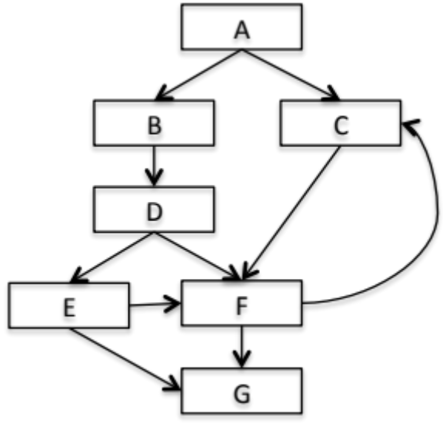
Which of the following statements related to the decision coverage goal is correct?
A) Decision D has not been tested completely.【无DF】
B) 100% decision coverage has been achieved.
C) Decision E has not been tested completely.
D) Decision F has not been tested completely.

9. An employee’s bonus is to be calculated. It cannot become negative, but it can be calculated to zero. The bonus is based on the duration of the employment. An employee can be employed for less than or equal to 2 years, more than 2 years but less than 5 years, 5 to 10 years, or longer than 10 years. Depending on this period of employment, an employee will get either no bonus or a bonus of 10%, 25% or 35%.
How many equivalence partitions are needed to test the calculation of the bonus?
A) 3 B) 5 C) 2 D) 4

10. Which one of the following techniques is structure-based?
A) Decision testing (Logical Coverage).
B) Boundary value analysis.
C) Equivalence partitioning.
D) State transition testing.

二、简答题（每题6分）
1. Why would a software tester like the spiral or iterative model better than the others?
为什么一个软件测试人员认为螺旋或迭代模型优于其他？
A：他们很早就参与了开发过程，并有机会发现早点问题，节省了项目时间和金钱。
- Why is it impossible to test a program completely?
A：除了最小的和最简单的程序外，还有太多的输入，太多的输出，以及太多的路径组合要充分测试。此外，软件规格可以是主观的，并以不同的方式解释。
- Explain what's wrong with this specification statement: When the user selects the Compact Memory option, the program will compress the mailing list data as small as possible using a Huffman-sparse-matrix approach.
It uses the phrase as small as possible. This is impossible to test because it's vague and imprecise（模糊的和不精确的）.The spec should state exactly what level of compression will take place.【尽可能压缩太含糊，不精确】
The statement also isn't code-free. It explains how the feature will work on the algorithm level.This doesn't belong in a specification. The user doesn't care how the compaction occurs,just that it does.【未做到代码无关性，用户不需要知道压缩如何发生。】
- If you're testing a program's ability to print to a printer, what generic test-to-fail test cases might be appropriate?
【可以尝试打印无纸或用卡纸。你可以把打印机脱机。你可以拔掉电源。你可以断开电缆。你可以尝试墨水不足印刷，也许甚至缺失墨盒。为了识别出所有的可能性，你可以看看打印机的操作手册，找出支持的错误处理，设法建立使用的错误情况。】
- What are the three basic states of a software bug's life cycle and the two common additional states?
【Open, Resolved, and Closed（打开、解决和关闭） are the basic states. Review and Deferred （审查和推迟）are two possible other states.】
三、应用题（每题20分）
1、 White-box
(1) Give a flow chart for the following source code.
(2) Analyze the basis path for the flow chart, and list the basis test paths.
(3) Design a suite of test cases to coverage all these paths.

Program list: binary search - c (simple)
1. /**
2. #include <stdio.h>
3. /**
4. * binary search (simple)
5. *
6. * @param
7. * arr pointer of array
8. * @param
9. * len length of array
10. * @param
11. * x target to search
12. *
13. * @return
14. index of target in the array,return -1 if not found,
15. */
16. int bin_search(int *arr,int len,int x) {
17. // indexs
18. int start = 0,end = len-1,middle;
19. while (end >= start) {
20. middle = (start + end) >> 1;
21. if (*(arr+middle)==x) {
22. return middle;
23. } else if(x < *(arr+middle)) {
24. end = middle - 1;
25. } else {
26. start = middle + 1;
27. }

28. }
29. // not found
30. return -1;
31. }

2、 Black-box
Design functional test cases for the following QQ login form.


（1）Design the effective and efficiency test cases.
（2）Explain the reasons why we select these test cases.

